**CHAPTER 3**

**METHODOLOGY**

In this chapter, the methodologies used throughout the study are described together with the diagram presentation. Here are the following sections that will be discussed in this chapter: Requirements Analysis, Requirement Documentation, Design of Software, System Product and/or Process, Development and Testing and Implementation Plan.

**REQUIREMENTS ANALYSIS**

In this section, researchers must first determine information requirements with regard to the specific organization under study. At this phase, the researchers need to know the details of the current system function of which the business or organization under study:

* Who (the people who are involved)
* What (the business activity)
* Where (the environment in which the work takes)
* When (the timing)
* How (how the current procedures are performed)

You need to discuss the existing process or system used by your beneficiary. You may provide a diagram or a flow chart that will visualize the current process they are using and highlight the existing problem into it. You may refer to the figure below, take note it should display their existing procedures.

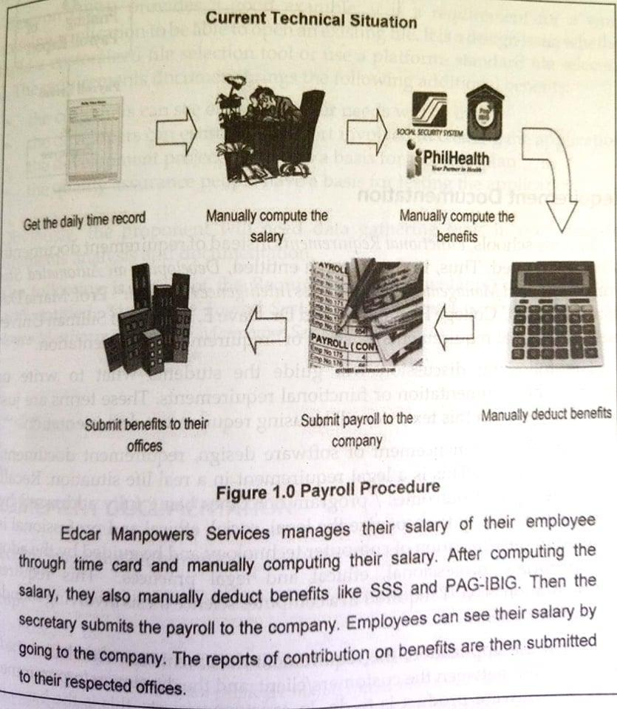

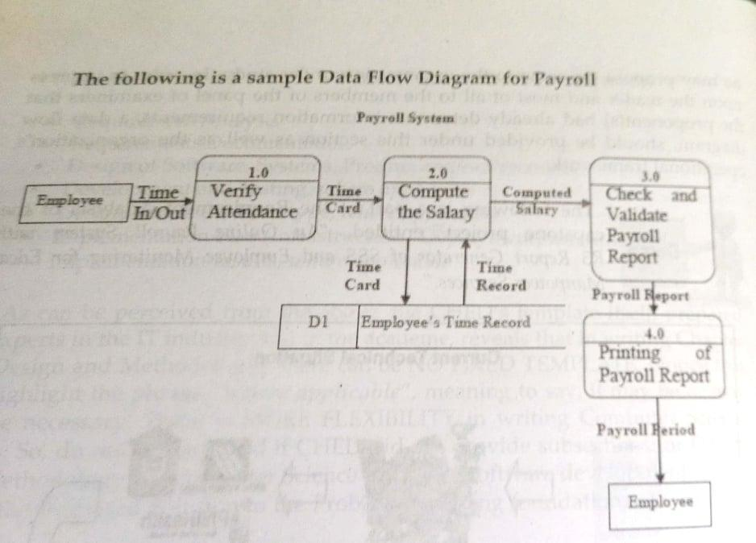

**REQUIREMENT DOCUMENTATION**

The requirement documentation establishes the basis for agreement between customers/client and the developers on what the software product is to do. Under this section, all software features are enumerated in details by proving story board showing how the software would look like if the same was already designed and coded.

You may provide a Functional Decomposition Diagram to discuss what your propose system will do, by discussing all important module include in your propose system.

**DESIGN OF SOFTWARE, SYSTEMS, PRODUCT AND/OR PROCESS**

In this section, the researchers should describe in detail how you will design the proposed system in accordance with standards. You may provide a Conceptual Framework of your study and a System Architecture to show your idea on how to identify, formulate and solve computing problems.

**DEVELOPMENT AND TESTING**

**Development Procedure**

In this section, the researchers should display what system development methodology should you be using and why have your choose it in the development of your propose system. Make sure to explain what actions that you will do for each phase of your chosen methodology.

**Testing Procedure**

You should also provide a testing procedure that will discuss how will you test the propose system, what are the area/modules that you will test, who will test and how many will test it. Provide what evaluation instrument that you will be using and what will be your statistical measuring tools that you will be using to evaluate your propose system.

**IMPLEMENTATION PLAN**

In this section, it describes how the propose system will be deployed, installed and transitioned into an operational system. The plan contains an overview of the system, a brief description of the major tasks involve in the implementation, the overall resources needed to support the implementation effort (such as hardware, software, facilities, materials and personnel) and any site-specific implementation requirements. Below is the sample implementation table.

